Mr Solman Ahmed of the Anokaa Restaurant
Solman Ahmed is the owner and inspiration behind Anokaa in Fisherton Street. His entrepreneurial skills have ensured that the Anokaa Restaurant is one of the most prestigious in Salisbury.

While studying Computer Engineering at Oxford Brookes University in 1992, Solman decided to risk all in his pursuit of a dream to become a successful restaurateur.

With a passion for Contemporary Indian Cuisine and a desire to provide true Indian Hospitality, he opened his first restaurant in Oxford during 1993. Starting as a complete novice in the industry, he was driven by a desire to excel in all respects. In 1997 he opened the restaurant in Estcourt Road, Salisbury.

‘Refreshingly different’ is how the Anokaa restaurant has been described, echoing the meaning of this Indian word. Much of Solman’s success can be attributed to his careful selection of highly motivated staff, some from respected world-renowned oriental establishments.

Through hard work and sheer determination he has developed Anokaa into a thriving business and this gave him the confidence to open a string of restaurants in the South of England. At Dorchester in 1998 followed by Shaftesbury in 2002 and Amesbury in 2005.

Each one exhibits his unique style of fine Indian food and hospitality. The Salisbury restaurant relocated to 60, Fisherton Street in 2004.

Respected in the community and as the father of three, Solman is a true example of a man who whole-heartedly embraced a challenge and accepted nothing less than outright success.

Through his achievements, he is now recognised and respected as being one of the region’s leading business entrepreneurs.

Come to the Guildhall on 21st September for what is sure to be an inspiring and entertaining evening in the company Mr Solman Ahmed, the FSB Salisbury Branch Committee, FSB members and their guests.



The Federation of Small Businesses

In association with


and

•
A Celebration of South Wiltshire
Food & Drink Dinner
•
Guest Speaker - Mr Solman Ahmed
of the Anokaa Restaurant
•
Thursday, 21st September 2006
7:00pm for 7:30pm
The Guildhall, Salisbury
Tickets £30 (including pre-dinner drinks, dinner & wines)
Why celebrate South Wiltshire Food & Drink?

The FSB has again teamed up with Business Link (Berks & Wilts) and Salisbury District Council for this Celebration Dinner as part of the Salisbury Food Festival.

South Wiltshire is fortunate in having a wide variety of food and drink produced in the area. We believe it is important to recognise the contribution that the producers make to the local economy and to the health of the local population. Local products produced by small businesses for the benefit of the community – something to be proud of.

Join us as we celebrate the very best of South Wiltshire Food & Drink in the fabulous surroundings of The Guildhall, Salisbury with guest speaker Mr Solman Ahmed from the Anokaa Restaurant.

Priced at only £30 per ticket, the Dinner will be the showpiece event of the Food Festival as well as that of the local FSB calendar. Please complete the tear-off booking form opposite and return to Hugh Davies, Hugh Davies Chartered Accountants, 35 Chequers Court, Brown Street, Salisbury, SP1-2AS by 7th September 2006. Special discounted price - book a table of 8 and only pay for 7 places at £210.

Local Businesses that are known to have contributed to this Celebratory Dinner as of this Invitation’s issue date include:

Top Line Catering Catering services
Chang Thong Thai Restaurant Starter
Greengages Main Course Meat
Britford Farm Shop Fresh Vegetables
Wylye Valley Wines Wine & Aperitif
Salisbury Health Foods Bottled Water
Chocolate Bar and Patisserie Ice Cream and Chocolates
Loosehanger Cheeses Cheese Board

Celebration of South Wiltshire Food & Drink 2006 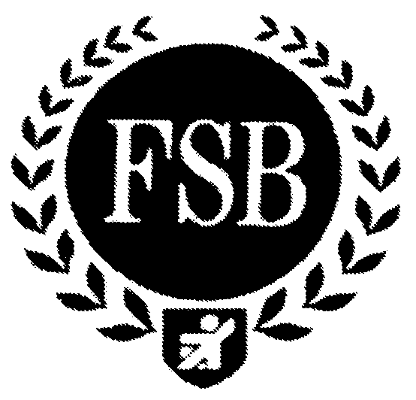
Booking Form please complete and return by 7th September, enclosing your cheque (£30.00 each) made payable to the FSB or provide card details below.

Name ………………………………………………………………………………………..
Address ………………………………………………………………………………………
……………………………………………………………..Post Code………………………
Telephone…………………………………………………………………………………….
eMail address…………………………………………………………………………………

Please list everyone in your party (Continue on separate sheet if required)

Name ……………………………………………………………………………………….

Name ……………………………………………………………………………………….

Name ……………………………………………………………………………………….

Name ……………………………………………………………………………………….

Name ……………………………………………………………………………………….

Check this box for special dietary considerations – we will contact you.
To secure your place, tear off and return this booking form, with a cheque for £30.00
per person (made payable to:- The Federation of Small Businesses)

To pay by credit or debit card, please supply the following details;
Name on Card……………………………………………..…..Signature…………………………..
Visa/Mastercard (delete one) Card No:..…..…..../……........../…………./…………
Issue date: Expiry date: Total amount: £………..….……

Send to: Hugh Davies (FSB Branch Treasurer) at Hugh Davies Chartered Accountants, 35 Chequers Court, Brown Street, Salisbury, SP1-2AS by 7th September 2006 [1]

